**Step by step create application XYLO**

**{ Contact List Management }**

composer create-project laravel/laravel tes-xylo

php artisan migrate

composer require laravel/jetstream

php artisan jetstream:install livewire

npm install

npm run dev

php artisan migrate

Php artisan serve

admin@gmail.com

admin123

agent@gmail.com

agent123

Display Application

1. Welcome

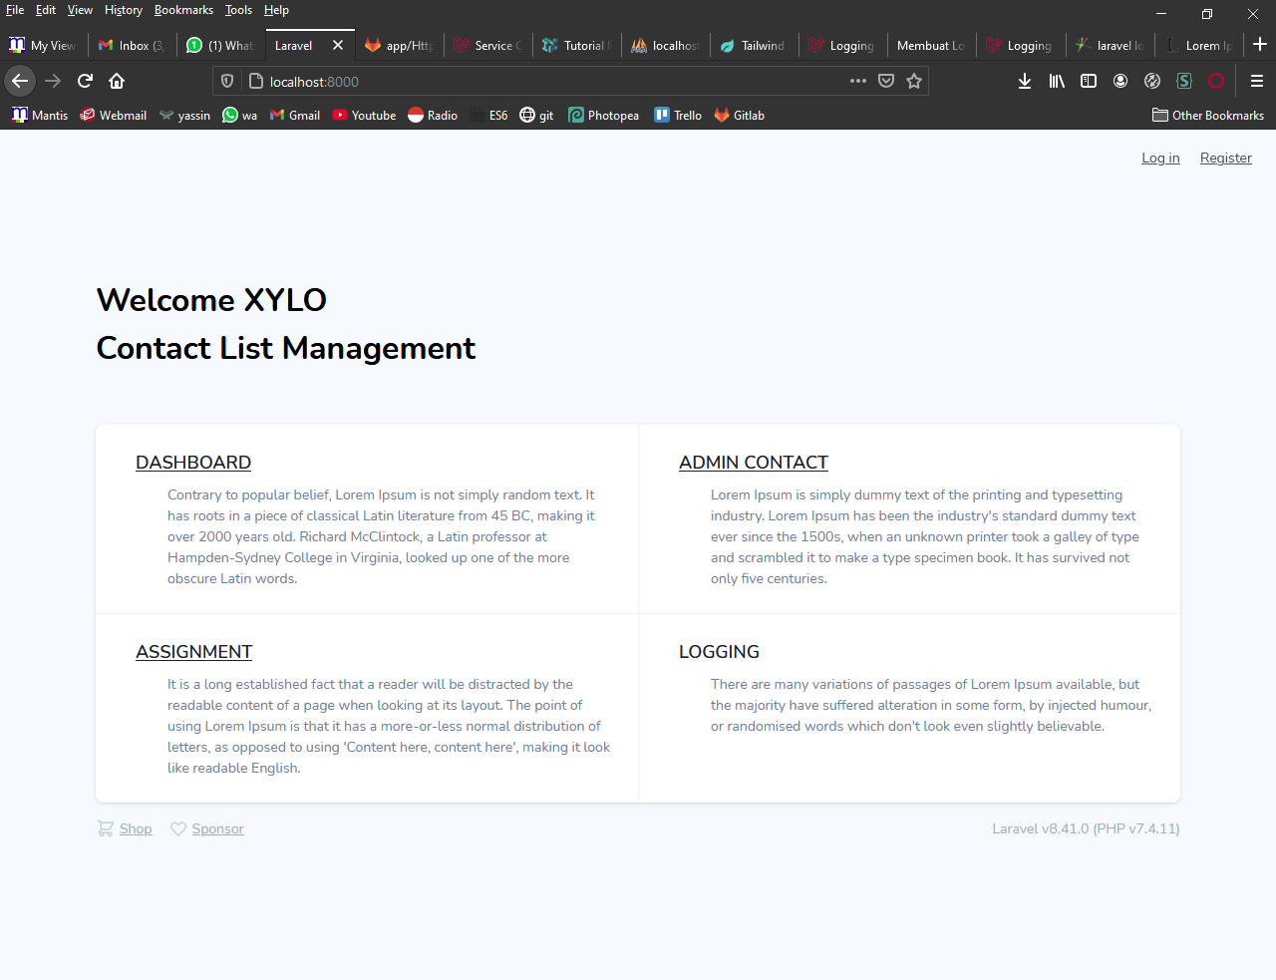

1. Register

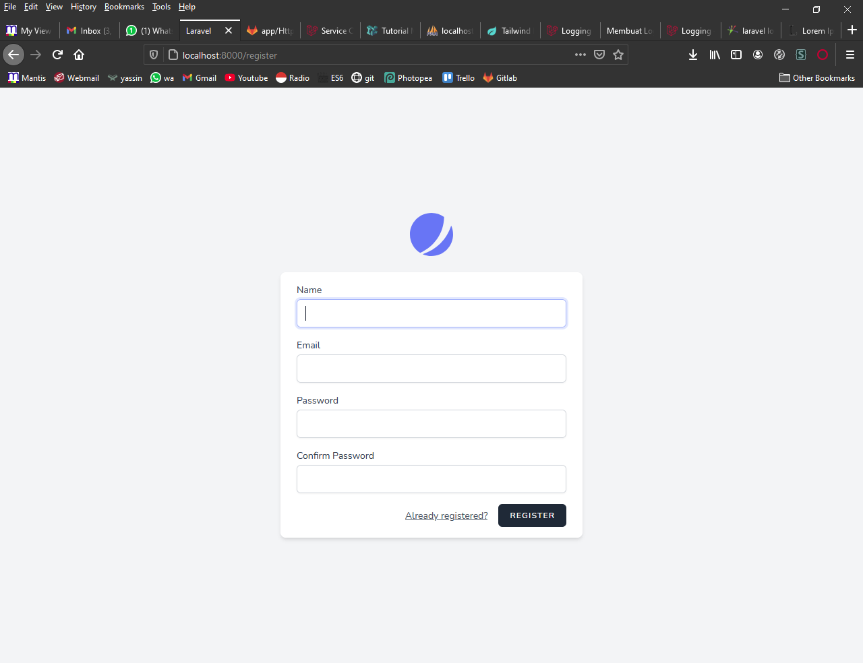

1. Login

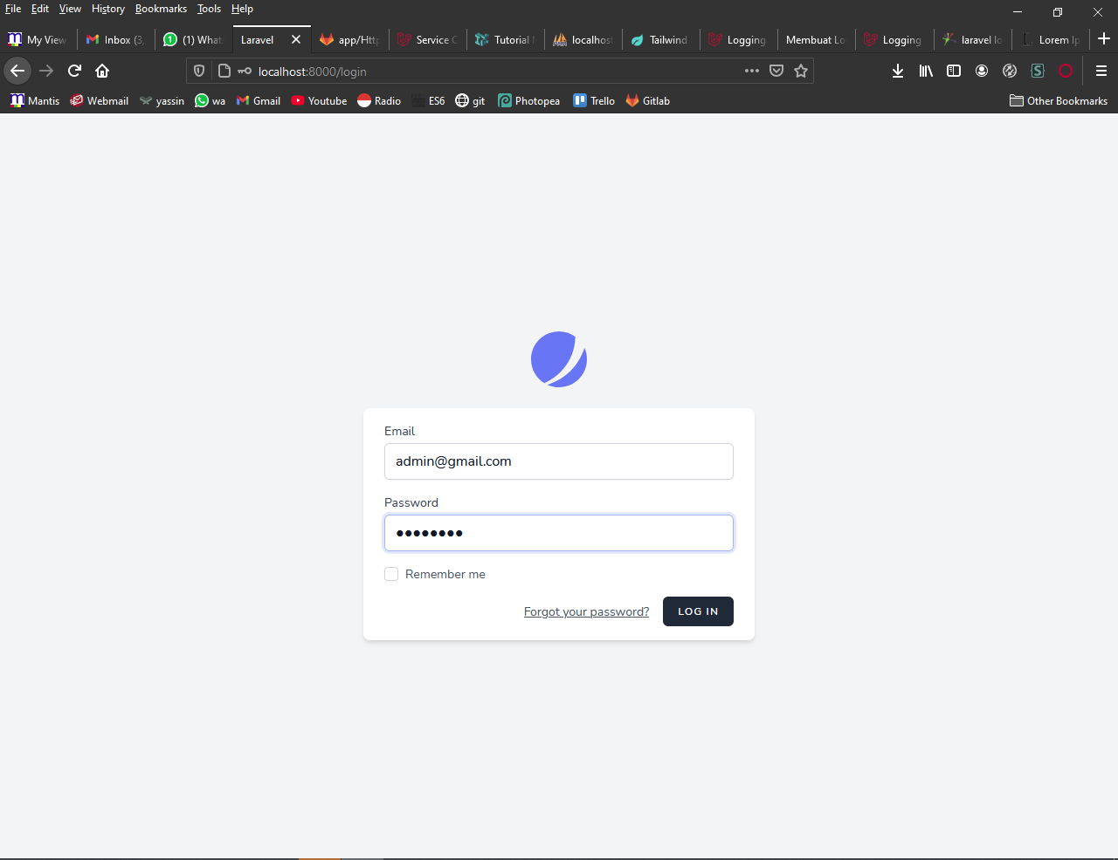

1. Dashboard

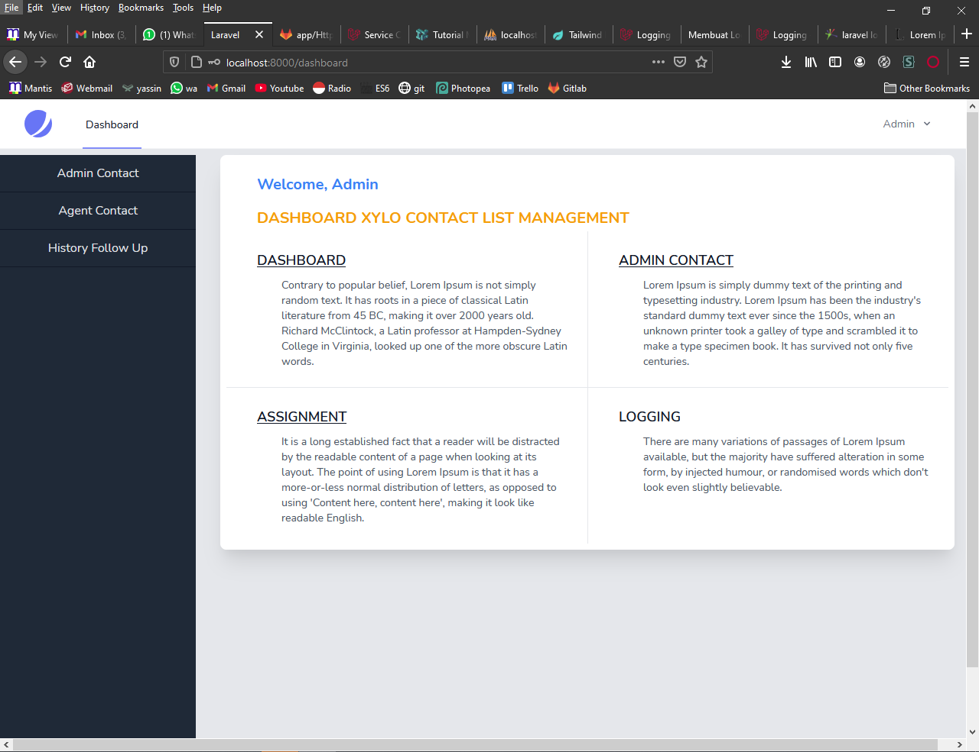

1. Page Admin contact

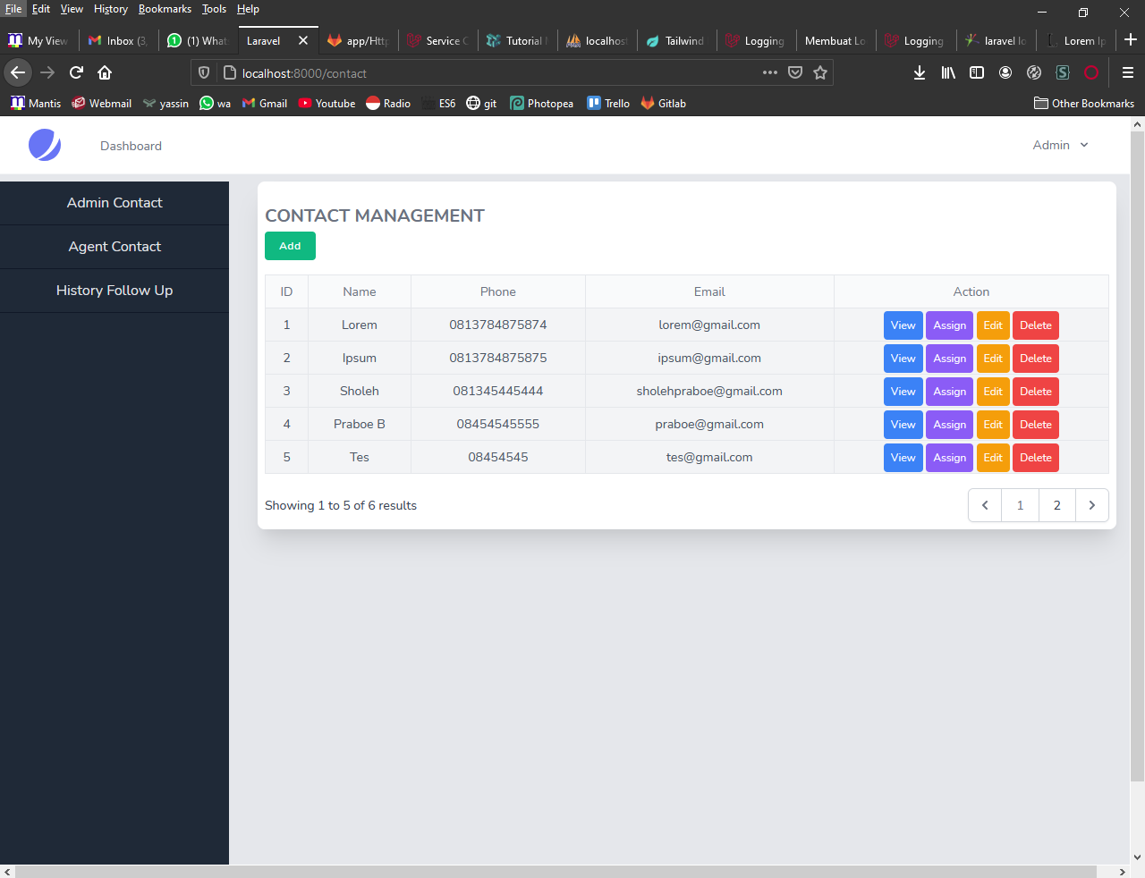

1. Page Agent Contact

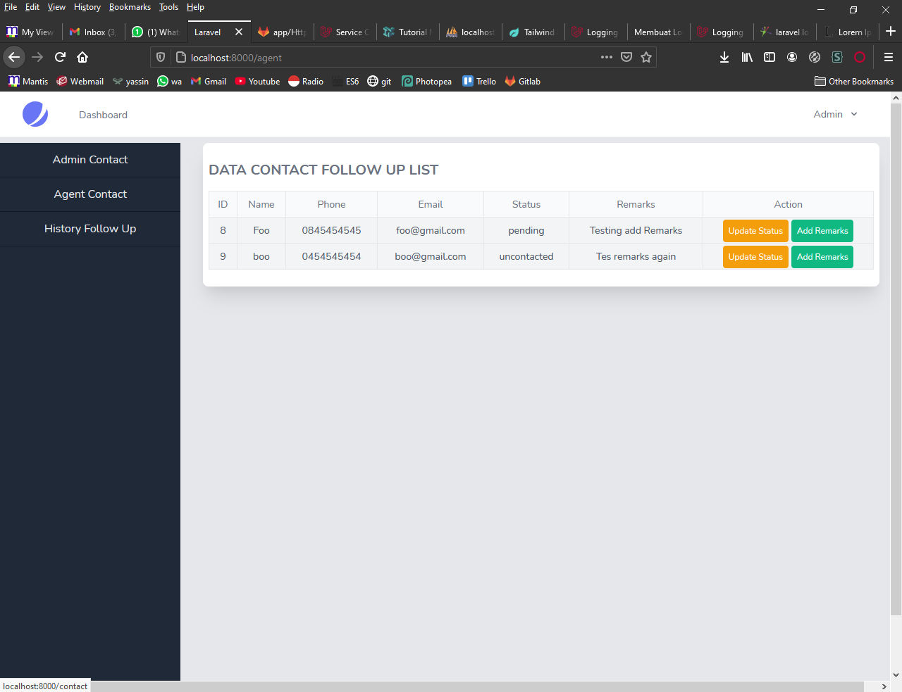

1. Page History follow up list

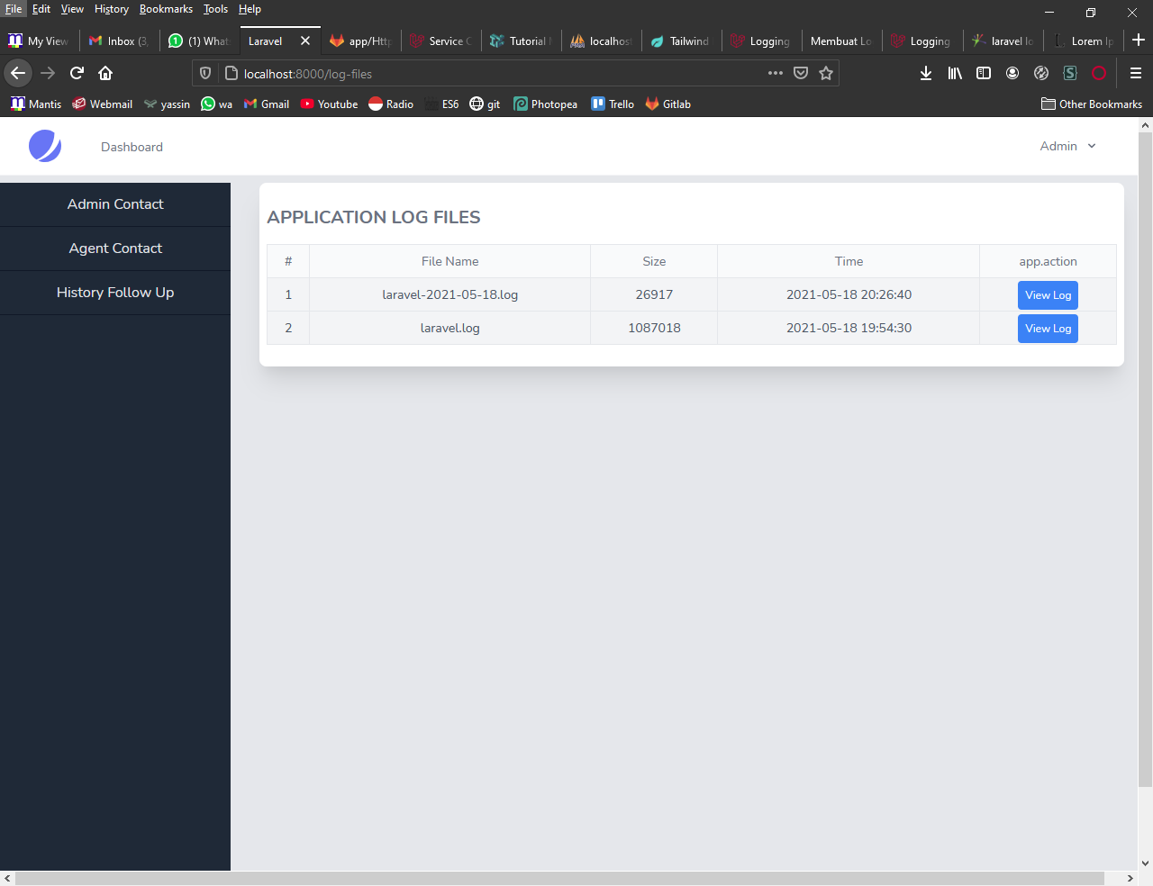

1. Menu Login Agent

